**INFO SECURITY FINAL PROJECT**

DIRECTORY TRIVERSAL ATTACK

**by Sheikh Muazzin Azeem(22-11087)**

Operating System:

* Kali

Software Used:

* Burp Suite

Website Intercepted:

* <https://portswigger.net/web-security/file-path-traversal/lab-simple>

Link for video file:

<https://drive.google.com/file/d/1jhVhpaMcH-6GJSkeP6sLUEmymGrbWW49/view?usp=sharing>

Steps followed for Attack:

* First, we updated burpsuite in our kali Linux.
* After that we exported CA certificate from our burpsuite and putted that in the web url authority certificate directory in our Firefox browser.
* After that we settled proxy in our Firefox browser. Initially the port was set to 8080 which is burpsuite port and set the URL to 127.0.0.1.
* After that we need to start our burpsuite and put the intercept on.
* Now we need to start the proxy on our Firefox.
* As soon as we start the proxy all the http requests would start to flow through our burpsuite.
* Then we need to load the site on which we want to attack.
* Now, select an image and its request would show in the burpsuite.
* Now, we need send that in interceptor and edit the file name with the directory name which we know that’s in the database.

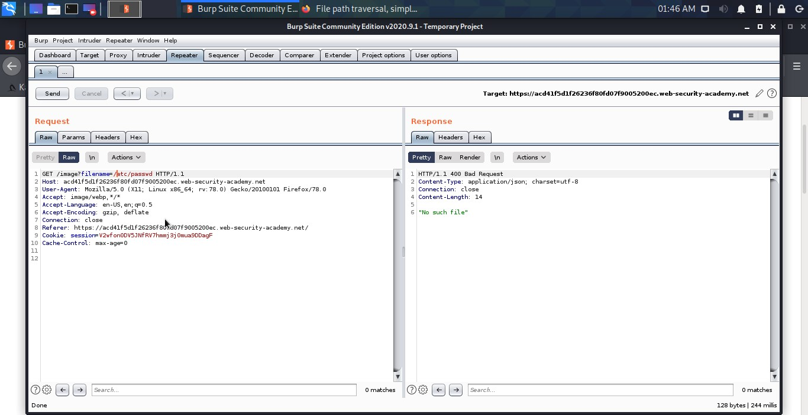

* Now we need to insert the payload on this by putting ../ Infront of the filename.

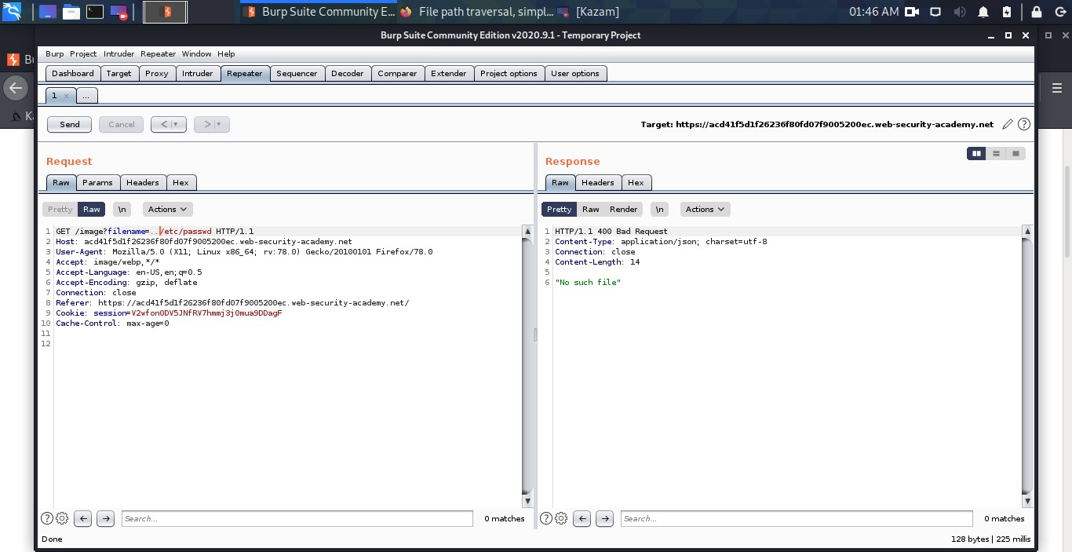

* We need to increase the payload until we retrieve the file from the server.

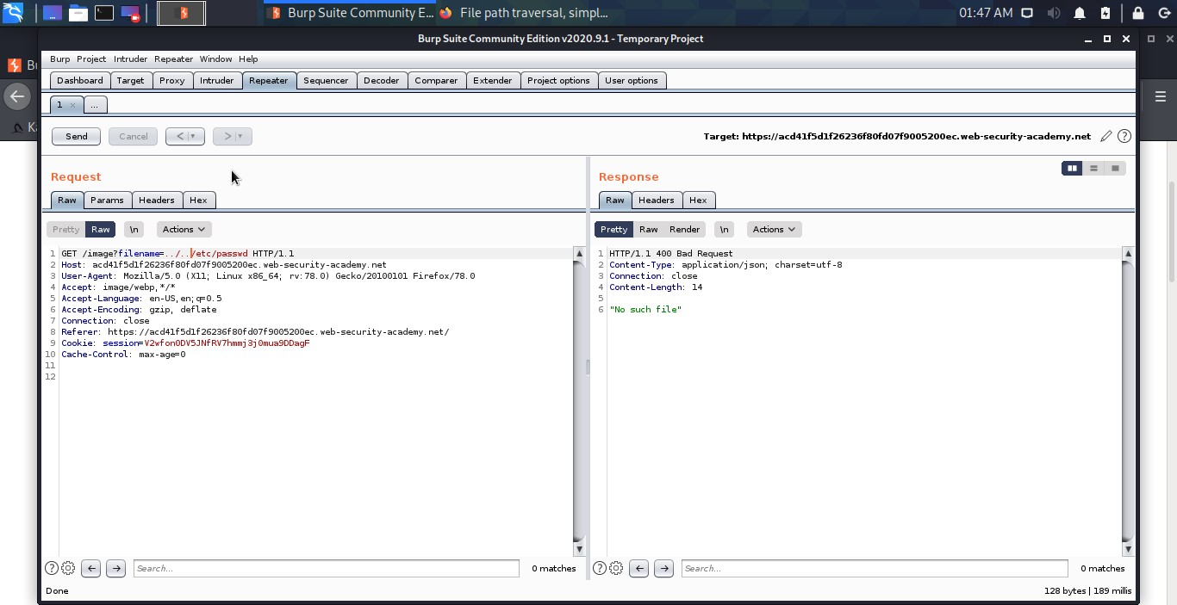

* So here we can see that our payload was kept on increasing and we retrieved that file from the server.

